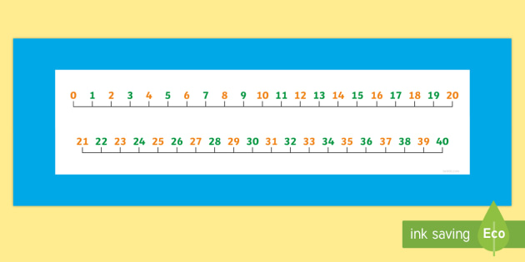

**Circle the correct answer.**

**Remember our grouping method makes it easier to count on from!**

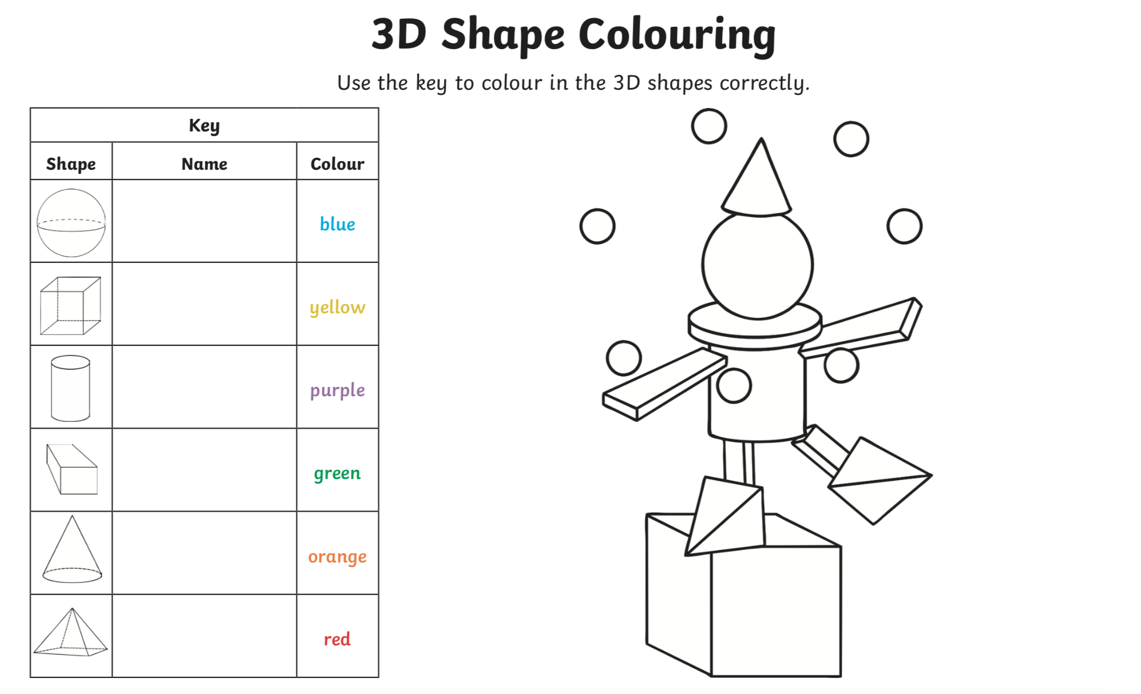

**Match the sentences to the correct pictures.**

**Match the sentences to the correct pictures.**

**Match the sentences to the correct pictures.**

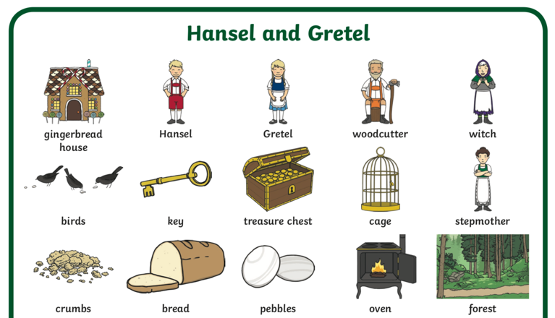

**Conjunctions**

and

because

so

but

**Adjectives**

**sour**

**creamy**

**delicious**

**fizzy**

**Chewy**

**Can you use different adjectives to describe your gingerbread house?**

**Can you add a conjunction? ________________________________________________________________________________________________________________________________________________________________________________________________________________________________________________________________________________________________________________________________**

**What was your favourite part of Hansel and Gretel story?**

**Can you find out 5 things about playing football?**

1. ____________________________________________________
2. ____________________________________________________
3. ____________________________________________________
4. ____________________________________________________
5. ____________________________________________________

