####

Name: ……………………………

YEAR 3 HOME LEARNING PACK

Dear Parents/Carers.

We have provided a homework learning pack for the Year 3 curriculum taught so far for Literacy, Maths, Topic and Science. For some activities, answers will be provided to enable you to check your child’s work.

We have also included information on great online learning resources for children to continue to have an engaging curriculum.

Please check the school website for any important updates.

Kind Regards,

Year 3 Team – Miss Ojukwu and Miss Jaiyesimi
Literacy

Comprehension – p. 4-9
Creative Writing - p.10-13
Spelling and Grammar- p. 14-15

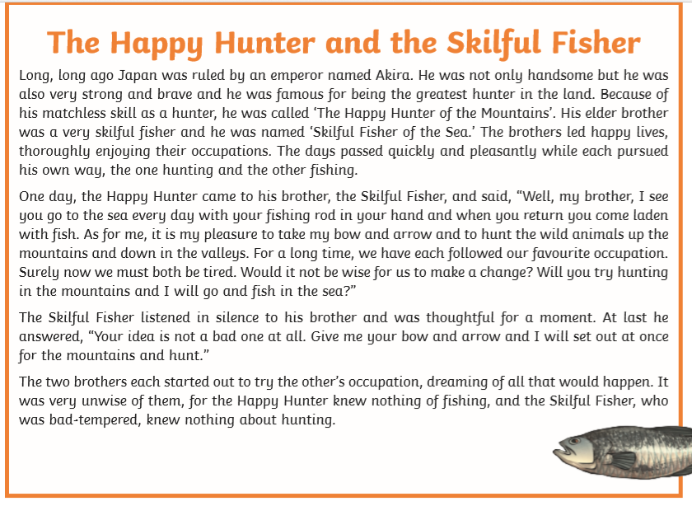
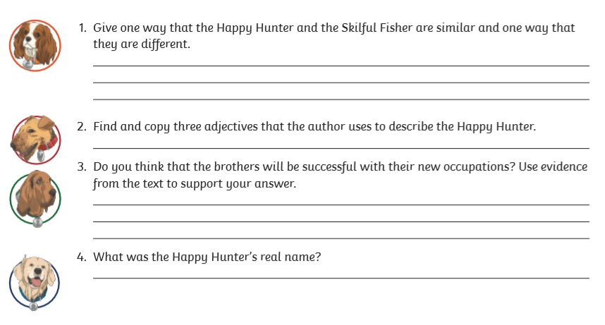
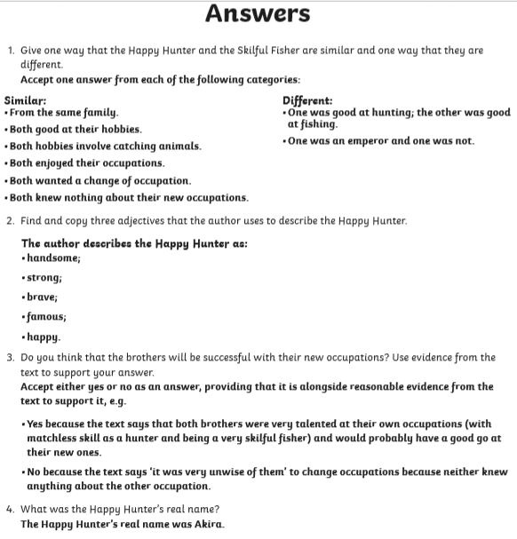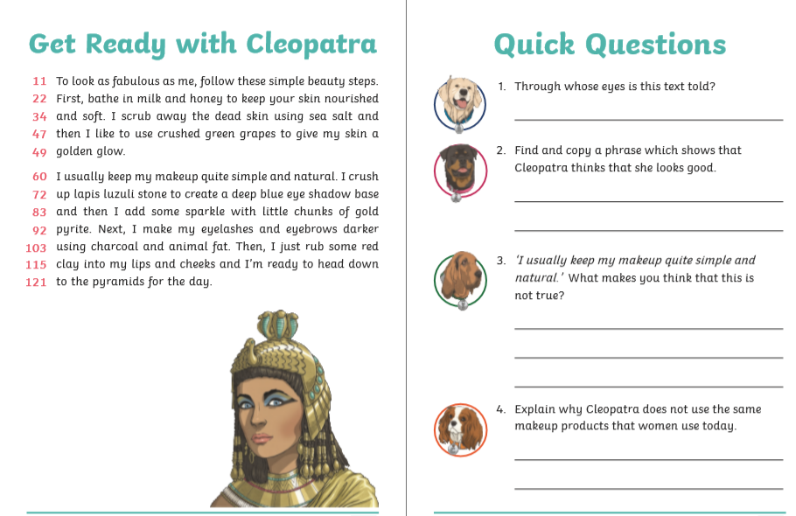
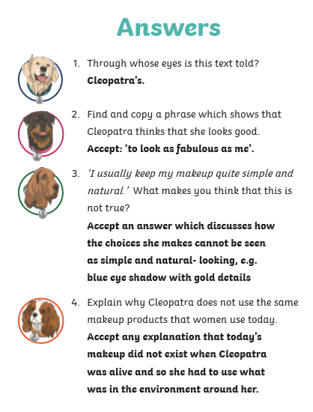

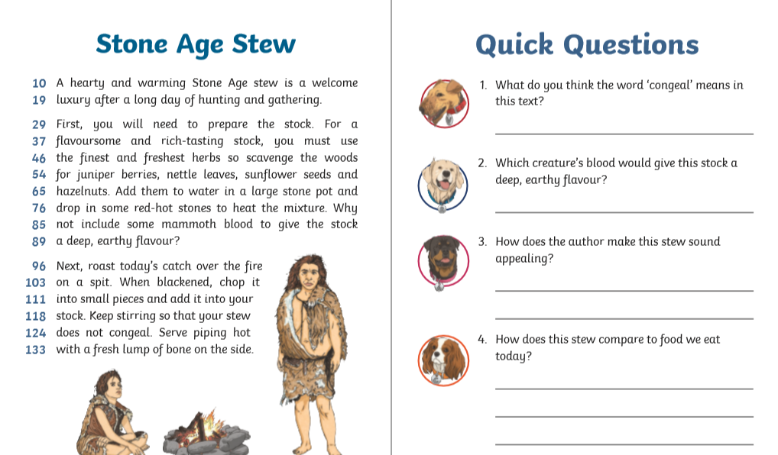

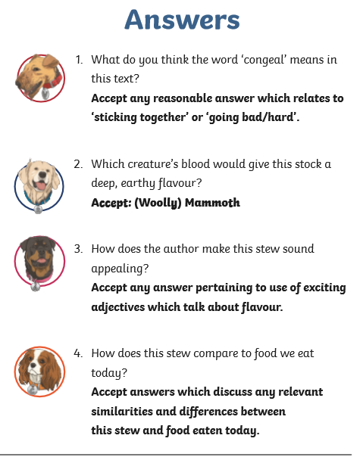

Creative Writing

Read the following story starter.

By moonlight she wandered around her familiar garden, watering her prize-winning tomatoes and talking animatedly to her blooming rose bushes. This was her favourite time, when she was alone in her precious garden, away from peering eyes…..

Task 1
Describe the character in this story, using a range of adjectives and adverbs. How do you imagine she looks, sounds, moves?

Task 2
Continue to develop the story, explaining the character’s curious behaviour. Add a twist to the tale to keep the reader interested.

Lined Paper provided on Next Page

…………………………………………………………………………………………………………………..
…………………………………………………………………………………………………………………..
…………………………………………………………………………………………………………………..
…………………………………………………………………………………………………………………..
…………………………………………………………………………………………………………………..
…………………………………………………………………………………………………………………..
…………………………………………………………………………………………………………………..
…………………………………………………………………………………………………………………..
…………………………………………………………………………………………………………………..
…………………………………………………………………………………………………………………..
…………………………………………………………………………………………………………………..
…………………………………………………………………………………………………………………..
…………………………………………………………………………………………………………………..
…………………………………………………………………………………………………………………..
…………………………………………………………………………………………………………………..
…………………………………………………………………………………………………………………..
…………………………………………………………………………………………………………………..
…………………………………………………………………………………………………………………..
…………………………………………………………………………………………………………………..
…………………………………………………………………………………………………………………..
…………………………………………………………………………………………………………………..
…………………………………………………………………………………………………………………..
…………………………………………………………………………………………………………………..
…………………………………………………………………………………………………………………..
…………………………………………………………………………………………………………………..
…………………………………………………………………………………………………………………..
…………………………………………………………………………………………………………………..
…………………………………………………………………………………………………………………..
…………………………………………………………………………………………………………………..
…………………………………………………………………………………………………………………..
…………………………………………………………………………………………………………………..
…………………………………………………………………………………………………………………..
…………………………………………………………………………………………………………………..
…………………………………………………………………………………………………………………..
…………………………………………………………………………………………………………………..
…………………………………………………………………………………………………………………..
…………………………………………………………………………………………………………………..
…………………………………………………………………………………………………………………..
…………………………………………………………………………………………………………………..
…………………………………………………………………………………………………………………..
…………………………………………………………………………………………………………………..
…………………………………………………………………………………………………………………..
…………………………………………………………………………………………………………………..
…………………………………………………………………………………………………………………..
…………………………………………………………………………………………………………………..
…………………………………………………………………………………………………………………..
…………………………………………………………………………………………………………………..
…………………………………………………………………………………………………………………..
…………………………………………………………………………………………………………………..
…………………………………………………………………………………………………………………..
…………………………………………………………………………………………………………………..
…………………………………………………………………………………………………………………..
…………………………………………………………………………………………………………………..
…………………………………………………………………………………………………………………..
…………………………………………………………………………………………………………………..
…………………………………………………………………………………………………………………..
…………………………………………………………………………………………………………………..
…………………………………………………………………………………………………………………..
…………………………………………………………………………………………………………………..
…………………………………………………………………………………………………………………..
…………………………………………………………………………………………………………………..
…………………………………………………………………………………………………………………..

Creative Writing - A Story Structure

Stories need an introduction, middle and ending. Use the starting lines given for each section to create your own story.

Introduction
Every Monday morning, it was the same old story. Jack Briggs would grab me on the way to school and demand my lunch money. For a quiet life, I’d hand it over willingly. _________________________________________________________________________________________________________________________________________________________________________________________________________
___________________________________________________________________

Middle
My revenge was carefully planned, surely nothing could go wrong ___________________________________________________________________
___________________________________________________________________
___________________________________________________________________
___________________________________________________________________

Ending
Some would say I was brave, others might say I was silly, but ___________________________________________________________________
___________________________________________________________________
___________________________________________________________________
___________________________________________________________________

Grammar
Common noun = person, place or thing that doesn’t need a capital letter e.g. man, shop, game, book, river.
Proper noun = person, place or name of something that starts with a capital letter e.g. Millie, Oxton, Europa Swimming Pool, River Dee.
Adjective = describing word
Verb = doing word (often ends in ‘ing’)
Task one
Underline all of the common nouns and circle all of the proper nouns in each sentence.
- Henry plays games on his computer.
- Mr Fan runs in the park every Sunday.
- Caroline lives in an apartment in Caston St.
- Dr Flood is flying on a plane to Norway.
- Neena’s birthday is in March.
Task two
Underline the adjectives in these sentences:
- The little man carried the heavy box across the wide street.
- The red house stood at the bottom of the deep valley.
- The narrow road was long and the children were tired.
- The log burned brightly in the old fireplace.
- The young lady sat down on the soft, green cushion.
- The busy bee flew to the bright flowers to gather honey.

Task three
Write a sentence using a noun, adjective and verb
___________________________________________________________________
___________________________________________________________________
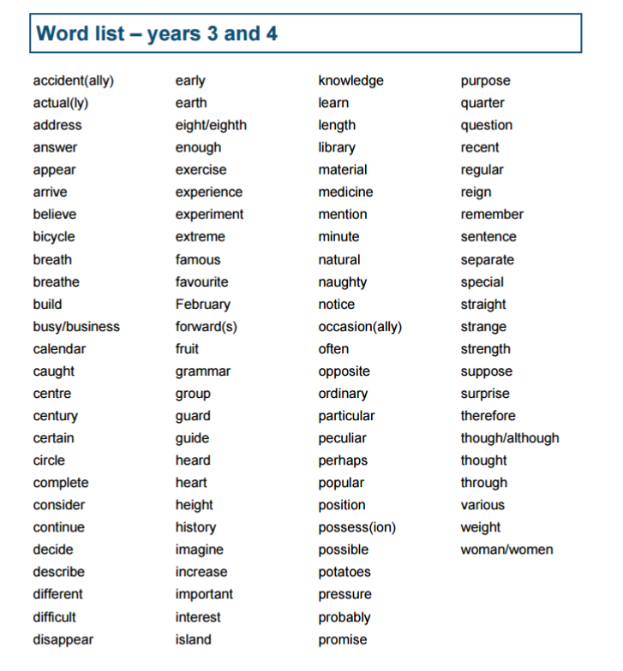
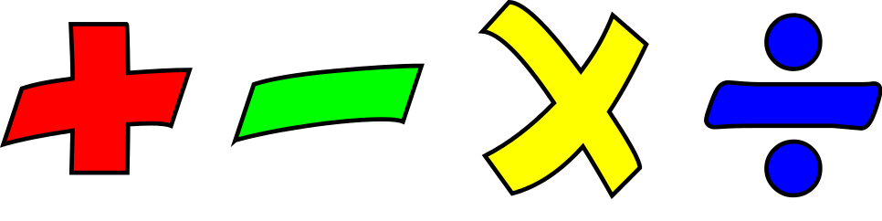
Maths
Times Tables
Addition and Subtraction
Multiplication and Division

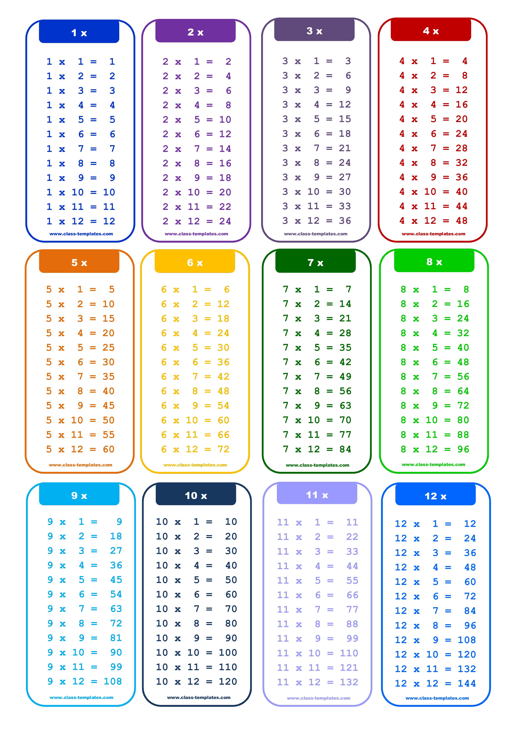
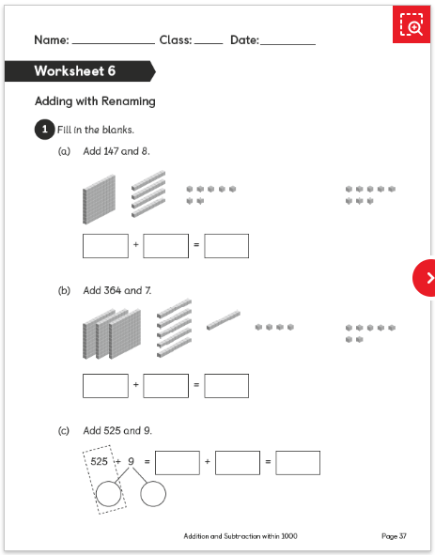
Super Nova Day 1
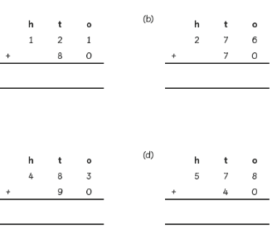
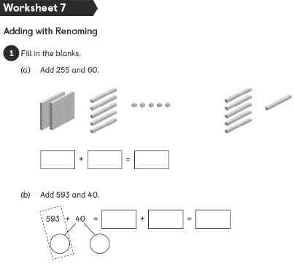
Whiz Kids Day 1
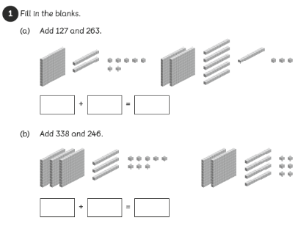
Superstars Day 1

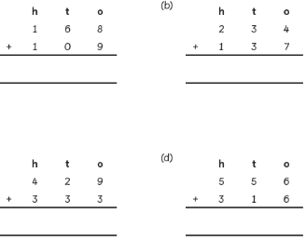
Bright Sparks Day 1
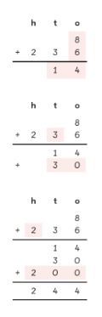  Method 1 | 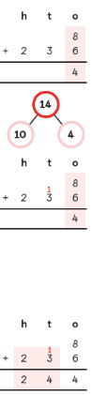  Method 2

Explain the two different methods step by step

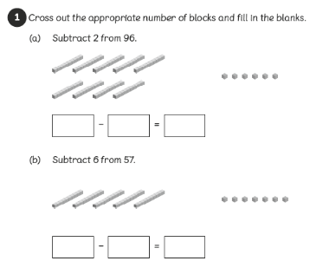
Supernova Day 2
Whiz Kids Day 2

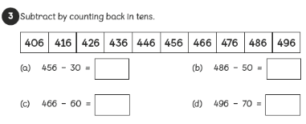
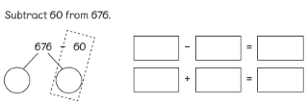
Superstars Day 2

Bright Sparks Day 2
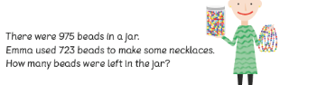

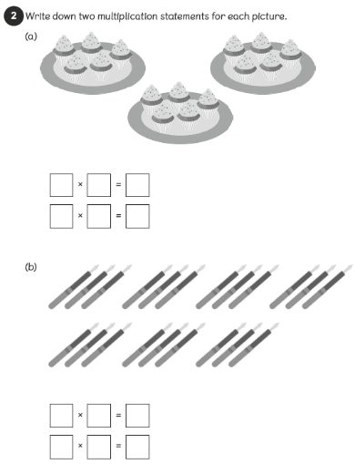

Supernova Day 3

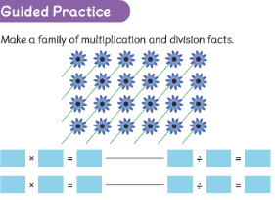
Whiz Kids Day 3

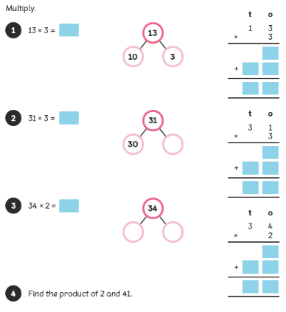
Superstars Day 3

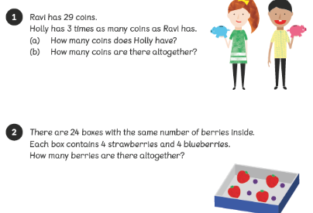
Bright Sparks Day 3

Supernova Day 4
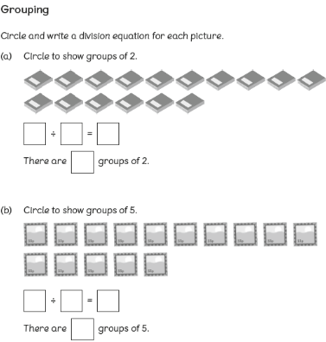

Whiz Kids Day 4
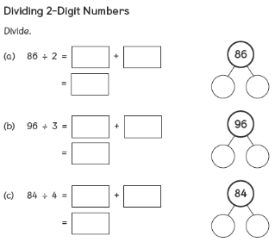

Superstars Day 4
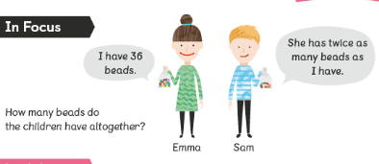
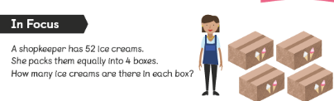
Bright sparks Day 4
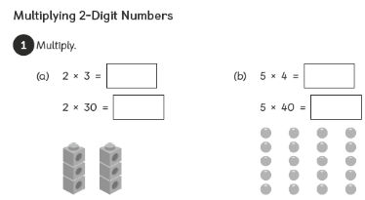
Supernova Day 5

Whiz Kids Day 5
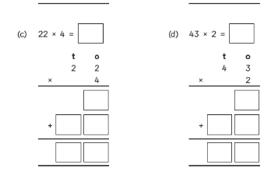
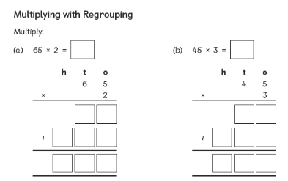
Super Stars Day 5

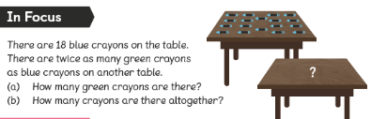
Bright Sparks Day 5

