Tottenham Stadium
Look at what the Tottenham Stadium used to look like.
Then look at what it looks like now.
Old Stadium | New Stadium
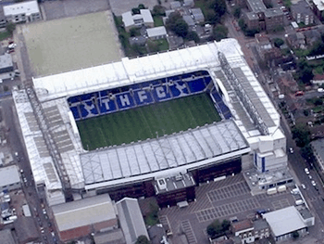 | 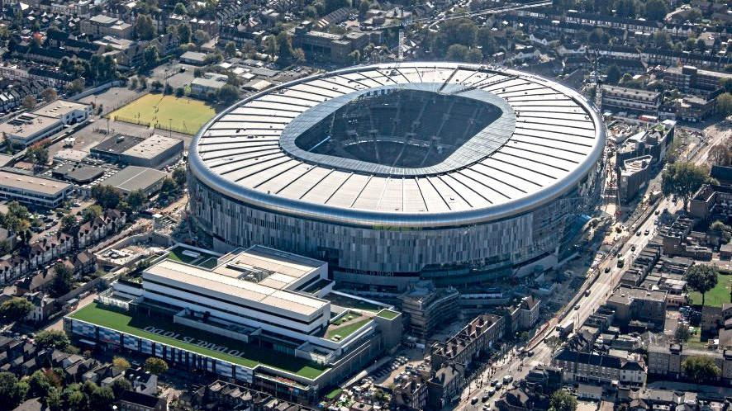

What is similar about the stadium and the area? Write a list.
What is different about the stadium and the area? Write a list.
Tottenham Stadium
Use your list of similarities and differences to write sentences about the stadium.

The old stadium had____________ but the new stadium has _____________.

