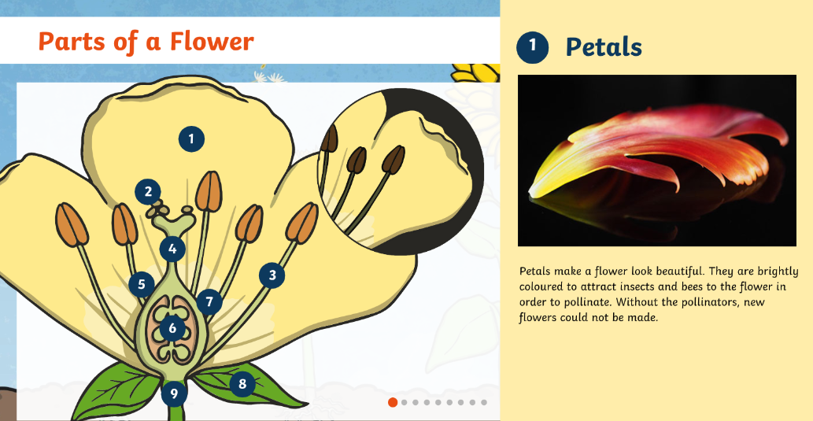

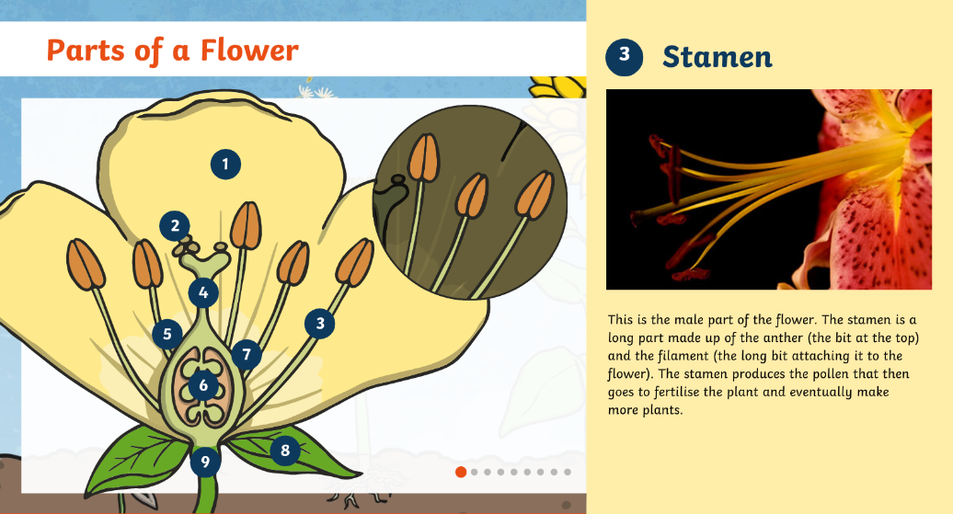

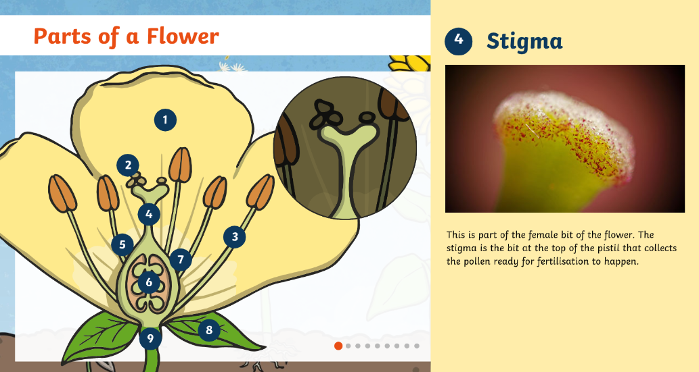

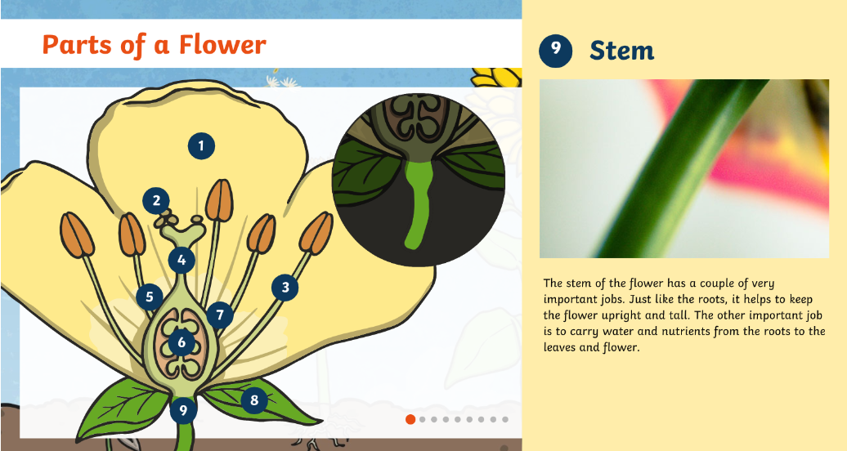

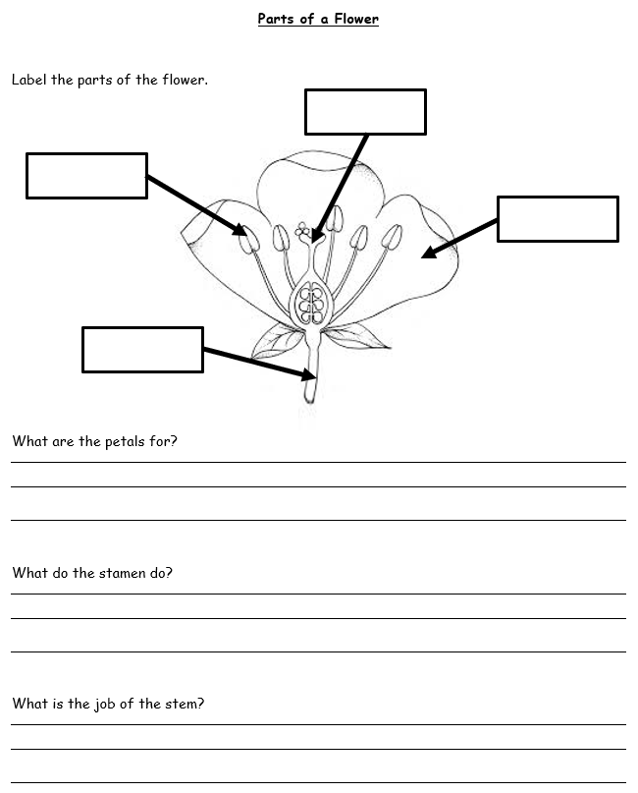

**Draw and label your favourite wild plant:**

**Write two facts about the plant:**

1. **________________________________________________________________**
2. **________________________________________________________________**

