[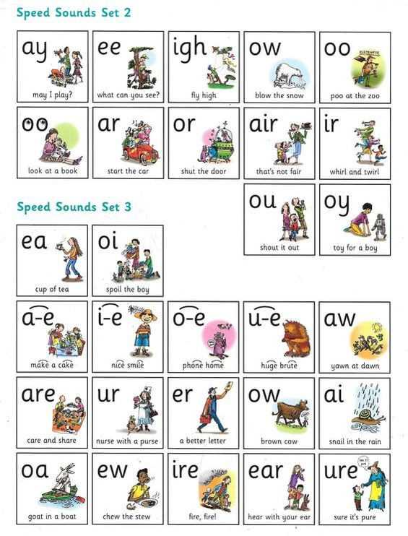](http://www.google.co.uk/url?sa=i&rct=j&q=&esrc=s&source=images&cd=&cad=rja&uact=8&ved=&url=http://www.google.co.uk/url?sa%3Di%26rct%3Dj%26q%3D%26esrc%3Ds%26source%3Dimages%26cd%3D%26ved%3D%26url%3Dhttp%3A%2F%2Fwww.longstone.derbyshire.sch.uk%2Fdahl-extra-page-1.html%26psig%3DAOvVaw3cNENRHpGUUi4cRP67GubN%26ust%3D1573314758256143&psig=AOvVaw3cNENRHpGUUi4cRP67GubN&ust=1573314758256143)**RWI**

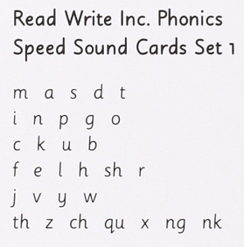**Order of sounds to be taught**