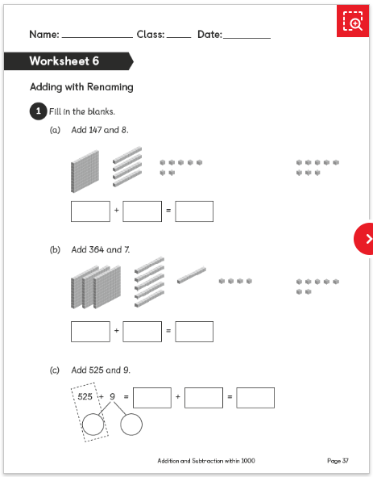**Super Nova Day 1**

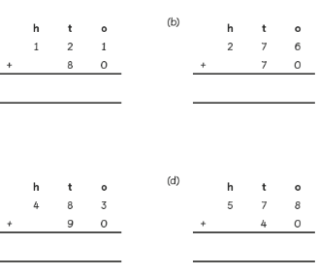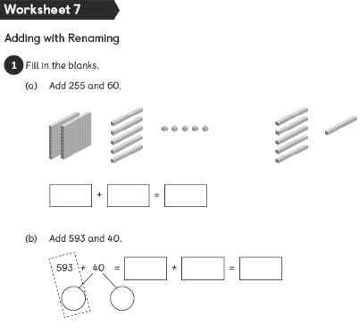**Whiz Kids Day 1**

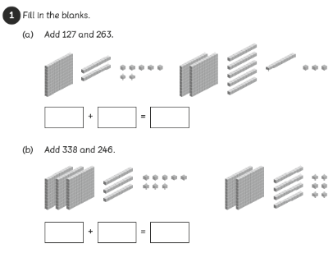**Superstars Day 1**

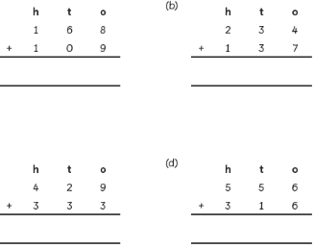

**Bright Sparks Day 1**

|  |  |
| --- | --- |
| Method 1 | Method 2 |
|  |  |

Explain the two different methods step by step

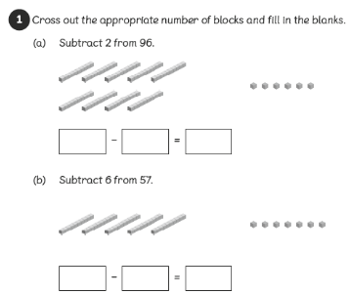**Supernova Day 2**

**Whiz Kids Day 2**

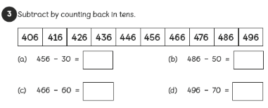

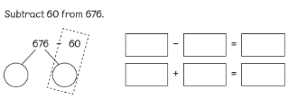**Superstars Day 2**

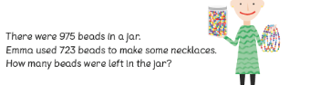**Bright Sparks Day 2**

**Supernova Day 3**

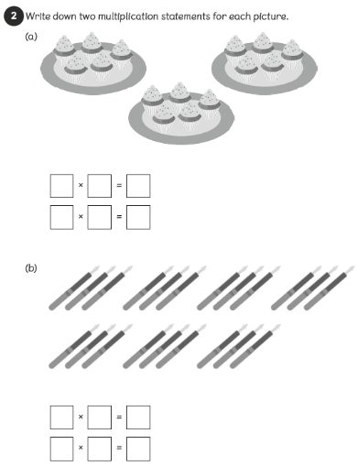

**Whiz Kids Day 3**

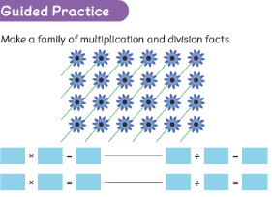

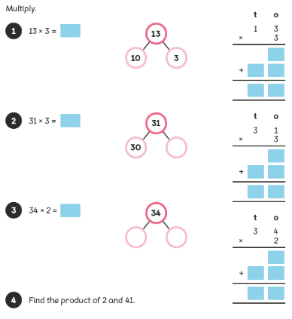**Superstars Day 3**

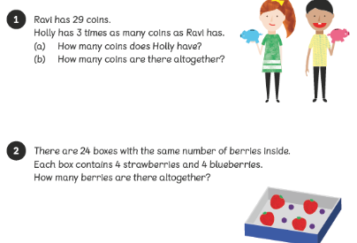**Bright Sparks Day 3**

**Supernova Day 4**

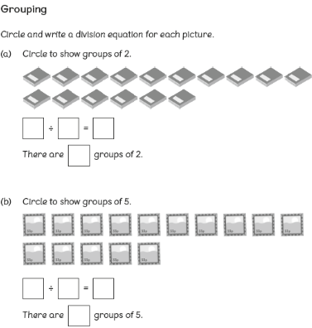

**Whiz Kids Day 4**

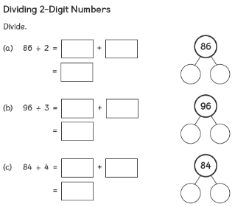

**Superstars Day 4**

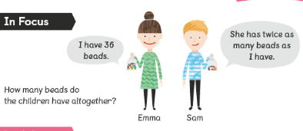

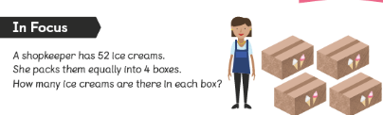**Bright sparks Day 4**

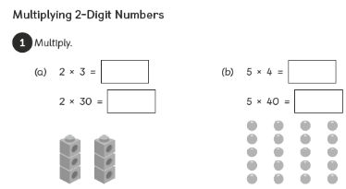**Supernova Day 5**

**Whiz Kids Day 5**

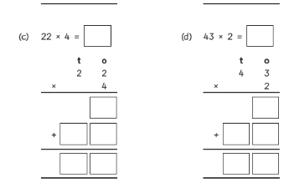

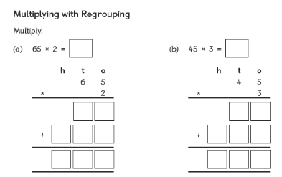**Super Stars Day 5**

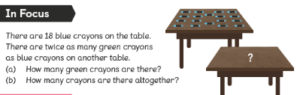**Bright Sparks Day 5**