Art Homework
Here is a virtual tour of an exhibition by artist Leyla Aliyeva at the Soho Art Gallery. The exhibition is called Live Life.
This is one of her paintings, Heart Bee.
https://www.eyerevolution.co.uk/tours/live-life/
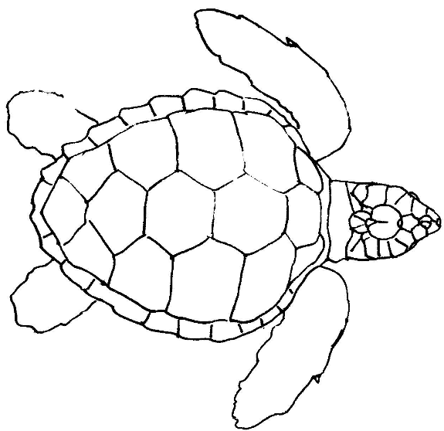
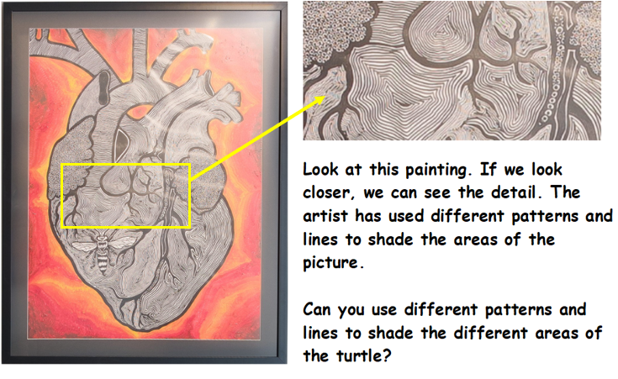
Practice your different patterns in the squares.

Here is another painting by Leyla.
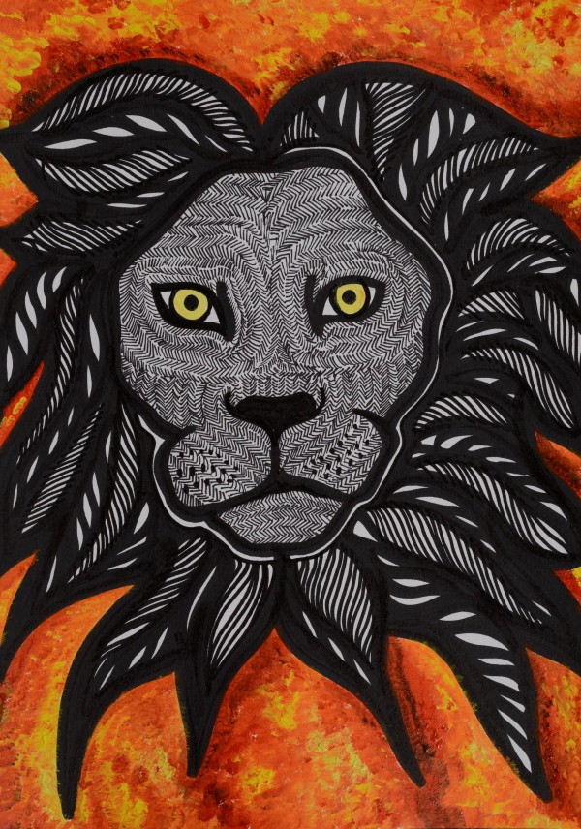
Can you shade a lion using patterns and lines?

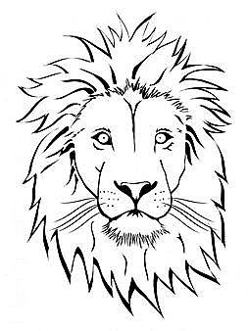

Here, you can take a virtual tour of the National Gallery:
https://www.nationalgallery.org.uk/visiting/virtual-tours/google-virtual-tour

This is Vincent Van Gogh:
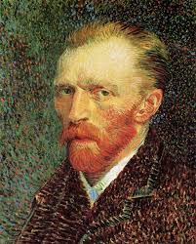
Vincent Van Gogh has some paintings in the National Gallery. This painting is in the gallery and is called Farms near Auvers.
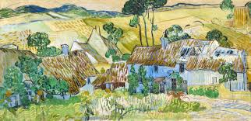
The painting is a view, maybe from his window, in France.

Can you draw the view from your window?

Practice shading the Value Scale:
Practice the different shading techniques:
