Home Learning Timetable
Monday | Tuesday | Wednesday | Thursday | Friday
Take 10  https://family.gonoodle.com/  Complete 10 minutes of daily physical activity. This could be jogging, aerobics or dancing. | Take 10  https://family.gonoodle.com/  Complete 10 minutes of daily physical activity. This could be jogging, aerobics or dancing. | Take 10  https://family.gonoodle.com/  Complete 10 minutes of daily physical activity. This could be jogging, aerobics or dancing. | Take 10  https://family.gonoodle.com/  Complete 10 minutes of daily physical activity. This could be jogging, aerobics or dancing. | Take 10  https://family.gonoodle.com/  Complete 10 minutes of daily physical activity. This could be jogging, aerobics or dancing.
Reading – 30 mins  Read a book and write about what you have read | Reading 30 mins  Read a book and talk about what you have read | Reading 30 mins  Read a book and write about what you have read | Reading 30 mins  Read a book and talk about what you have read | Reading 30 mins  Read a book and write about what you have read
Maths  https://www.topmarks.co.uk/maths-games/daily10  8x  https://www.bbc.co.uk/bitesize/topics/zsjqtfr  Place Value  Watch the video and complete the day 1 worksheet. | Maths  https://www.topmarks.co.uk/maths-games/daily10 7x  https://www.bbc.co.uk/sport/av/supermovers/42626762  What are Decimals? Watch the video and complete the day 2 worksheet. | Maths  https://www.topmarks.co.uk/maths-games/daily10  12x  https://www.bbc.co.uk/bitesize/topics/zh8dmp3  Rounding and estimating.  Watch the video and complete the day 3 worksheet | Maths  https://www.topmarks.co.uk/maths-games/daily10  9x  https://www.bbc.co.uk/bitesize/topics/zhdwxnb  Fractions.  Watch the video and complete the day 4 worksheet. | Maths  https://www.topmarks.co.uk/maths-games/daily10  11x  Multiplying 3 digit numbers  complete the day 5 worksheet.
Hand writing  Practice writing a line of each letter in your homework book. Leave a finger space between each.  a c d g o  Write one line of each word  according  groggy  accredited | Hand writing  Practice writing a line of each letter in your homework book. Leave a finger space between each.  f g j p q y  Write one line of each word  foggy  jacquard  puffy | Hand writing Practice writing a line of each letter in your homework book. Leave a finger space between each.  b d f h k l t  Write one line of each word  kilt  battered  hiking | Hand writing  Practice writing a line of each letter in your homework book. Leave a finger space between each.  a e i o u  Write one line of each word  lear  flour  imperious | Hand writing  Practice writing a line of each letter in your homework book. Leave a finger space between each.  m n r s v w x z  Write one line of each word  minors  woven  existing  zephyr
English  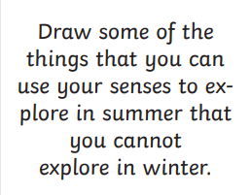  Write 5 sentences describing the experiences.  Now write a recount of an event you may have experienced.  Remember – first person, past tense, chronological order, why, who, when, where, how | English  Complete the comprehension number 1 | English  Complete the comprehension number 2 | English  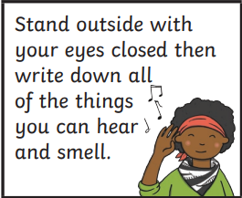  Write a poem using some of the words listed about what you hear and smell when you go outside. | English 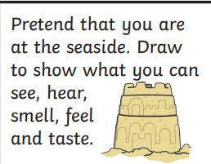  Now describe your first step onto the beach.
Spelling  https://www.collinsdictionary.com/  accommodate, accompany, according  Learn meaning, use in 2 sentences. | Spelling  https://www.collinsdictionary.com/  physical prejudice privilege  write 5 times in Homework Book in cursive.  Learn meaning, use in 2 sentences. | Spelling  https://www.collinsdictionary.com/  develop dictionary disastrous  write 5 times in Homework Book in cursive.  Learn meaning, use in 2 sentences. | Spelling  https://www.collinsdictionary.com/  variety, vehicle, yacht  write 5 times in Homework Book in cursive.  Learn meaning, use in 2 sentences. | Spelling  https://www.collinsdictionary.com/  controversy convenience correspond  write 5 times in Homework Book in cursive.  Learn meaning, use in 2 sentences.
Topic  Art- | Topic  Science  Draw a circuit. Your circuit needs to contain two components.  - Write a safety manual for using your circuit.  - What materials will you use? What will be your conductors? What will be your insulators?  - Have you used the correct scientific symbols? | Topic  ICT  Log in to purple mash  Complete two levels of the Logonator.  https://www.purplemash.com/sch/stjohnn18 | Topic  History  Research project  Famous people from Enfield – how did they contribute to society  1600-now | Topic  RE  Who were The People of God? Can you mindmap everything you know about The People of God.  Choose one story from the old testament and write it in your own words.
Story time  Ask your parent/ carer/ sibling to read to you. | Story time  Ask your parent/ carer/ sibling to read to you. | Story time  Ask your parent/ carer/ sibling to read to you. | Story time  Ask your parent/ carer/ sibling to read to you. | Story time  Ask your parent/ carer/ sibling to read to you.

Links to websites BBC bitesize https://www.bbc.co.uk/bitesize Studyzone https://www.studyzone.tv/ Purple mash https://www.purplemash.com/sch/stjohnn18 Topmarks https://www.topmarks.co.uk/

