[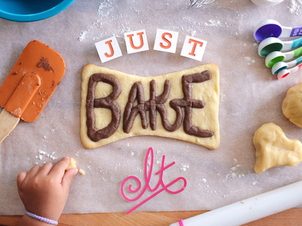](https://www.google.co.uk/url?sa=i&rct=j&q=&esrc=s&source=images&cd=&cad=rja&uact=8&ved=2ahUKEwiei7inoL_aAhWNHRQKHeBaASoQjRx6BAgAEAU&url=https://dribbble.com/shots/1729659-Just-Bake-It&psig=AOvVaw0dRsihinP7qW839i4KS_PH&ust=1523983826702999)

Bake It!

Write your own recipe for a 3 course meal.

Write your own cake recipe.

Design and create packing for a drink or food item.

Write a diary food log for one week.

Create your own smoothie to bring in and share with the class.

Create your own advert for a new food product that you have created.

Create your own healthy salad and your recipe.

Make your own salad and bring it in to share.

Bring in a sample of native dish for the class to share.

Year 5 Homework SUMMER Two

Choose 1 activity to complete each week and hand in to your class teacher on Thursday morning. You should complete at least 5 activities, but you may do more if you wish.