[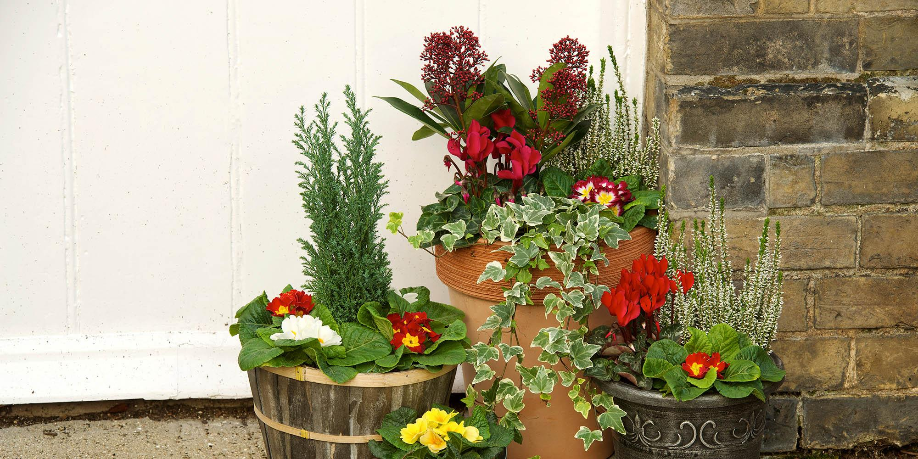](https://www.wyevalegardencentres.co.uk/tips-and-advice_choosing-the-perfect-plant-pot-for-small-spaces)

Oceans day 10th June

Please can you talk together about keeping the ocean clean so the sea creatures can be happy

You might like to make your own sea creature to add to our whole school display.

Gods wonderful world - looking after our world.

Can you find out what things have to be put in the recycling bin at home?

You might like to send in pictures of what you have found at home that can be recycled.

[EYFS@Stjohnandjames.enfield.sch.uk](mailto:EYFS@Stjohnandjames.enfield.sch.uk)

My favourite flower – Draw a picture of your favourite flower/plant. Think carefully about what it looks like and what colours you can see. Once you have drawn your picture write a sentence about the plant/flower you have drawn.

Reception Homework Summer 2

Choose 1 activity to complete each week and hand in to your class teacher on Thursday morning. You should complete at least 6 activities, but you may do more if you wish.

In Reception I have loved. . . .

As you come to the end of your year in Reception draw a picture and write about what you have most loved doing in Reception this year.

Think about what you can do now that you didn’t know how to when you first started.

Counting

Can you count how many trees you see in your journey to school? How many different coloured flowers can you see on your way to school or in your garden?

Write your own addition sentences adding the trees and flowers together.

Plants and flowers

What is growing?

On your journey to or home from school take a picture of something that you see growing. Send it in to [EYFS@Stjohnandjames.enfield.sch.uk](mailto:EYFS@Stjohnandjames.enfield.sch.uk)