[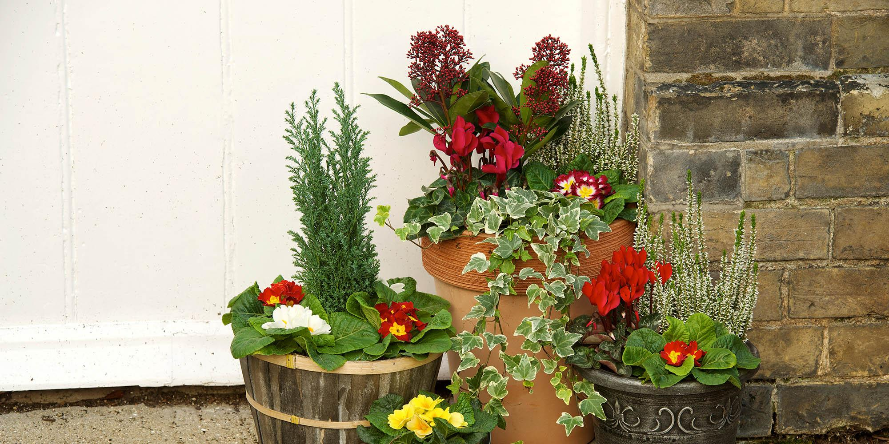](https://www.wyevalegardencentres.co.uk/tips-and-advice_choosing-the-perfect-plant-pot-for-small-spaces)

Shapes

Can you find different shapes in your home and send us a picture of them.

[EYFS@Stjohnandjames.enfield.sch.uk](mailto:EYFS@Stjohnandjames.enfield.sch.uk)

Nursery Homework Summer 2

Choose 1 activity to complete each week.

You can ask a grown up to help you write things down and bring it in to show your teachers and friends in Nursery

Counting

Can you count how many trees you see in your journey to school?

How many different coloured flowers can you see on your way to school or in your garden?

Gods wonderful world looking after our world.

Can you find out what things have to be put in the recycling bin at home?

Collecting boxes

Please can you bring in small boxes so we can use them to make models.

What is growing?

On your journey to or home from school take a picture of something that you see growing. Send it in to [EYFS@Stjohnandjames.enfield.sch.uk](mailto:EYFS@Stjohnandjames.enfield.sch.uk)

Plants and flowers

Growing things

Take your pot home and look after your seed. What do you have to do so it will grow?

Oceans day 10th June

Please can you talk together about keeping the ocean clean so the sea creatures can be happy.