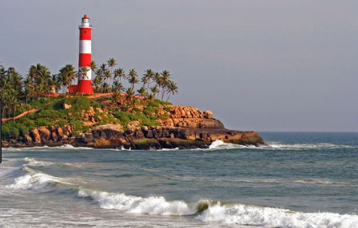

Create a model of a lighthouse.

**2 house points**

Design and write a postcard from a place you would love to visit. (either abroad or at home)

**2 house points**

Research the top 3 holiday destinations in the world.

Explain why they are the most popular.

**2 house points**

Imagine you are stranded on a desert island.

Write a letter, asking for someone to come and rescue you.

**5 house points**

Make a 3D model of a mode of transport you would use to go on holiday.

**2 house points**

Make a model of a beach hut.

**2 house points**

Imagine you have gone on holiday. Write a diary entry about your day.

Remember to start with Dear Diary, write in 1st person and the past tense.

**5 house points**

Write a story about being stranded on a tropical island.

Remember to use good description – adjectives, adverbs, noun phrases.

**5 house points**

Imagine you are at the beach. Write a poem about the seaside**.**

**5 house points**

Write a fact file about how pollution (littering) is having an impact on England’s beaches.

**5 house points**

Design a poster for a holiday.

**2 house points**

**Year 2 Choosing Homework**

*‘Hooray! Let’s Go on Holiday!’*

Remember you do not have to do all of these, but try to complete one piece of choosing homework each week. Try to complete 1 written piece of homework each week.

Homework needs to be handed in by Thursday.

***Thanks***

***The Year 2 team.***

Hooray! Let’s Go on Holiday!