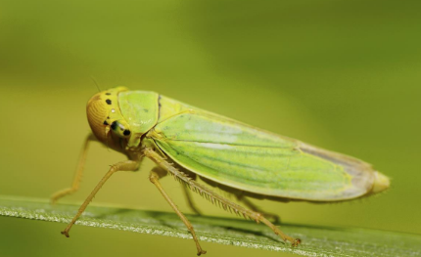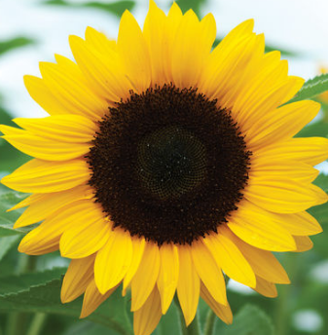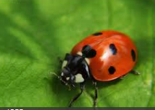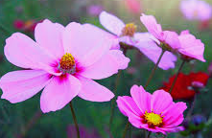

**FLOWERS AND INSECTS**

**Vincent Van Gogh. Write about what you think about his sunflower paintings and draw or paint your own version of The sunflower.**

**Make an imaginary garden. You will need an old shoe box. Place it on its side and build a garden inside it. You could use pictures of flowers and insects cut from magazines.**

**Draw or paint your garden. Be creative. You can use plasticine or other natural materials.**

**Go for a walk in the park. Take photographs or draw pictures of all the flowers and insects you see**.

**Use the internet to find out about one of the most famous flower paintings in history.**

**Year 1 Homework- Summer 1**

Choose one activity to complete each week and hand in to your class teacher on **Thursday morning.**  You should complete at least five activities, but you can do more if you wish.

**Look closely at one flower. Draw it. Try to label the parts of the flower you know. Can you identify the petals, leaves, seeds and stem?**

**Look closely at different types of seeds. Cut open an apple, orange, grapes or tomatoes. Collect these seeds to bring into class.**

**Investigate which flowers attract which insects.**