[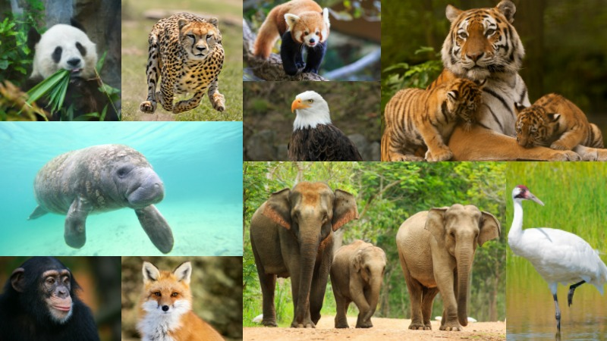](https://www.google.co.uk/url?sa=i&rct=j&q=&esrc=s&source=images&cd=&cad=rja&uact=8&ved=2ahUKEwiaofzonr_aAhXJOhQKHQzcDKEQjRx6BAgAEAU&url=https://www.pinterest.co.uk/pin/480337116497369468/&psig=AOvVaw3ttyLZ3JwNSn3-9ysz7SMm&ust=1523983343045613)

Create a poem about extinct animals.

Existing Endangered and Extinct Animals

Design a 3D model of an animal habitat.

Research an endangered animal.

Design a billboard to save animals.

Create a song or rap about an extinct animal.

Create your own petition to save an endangered animal.

Research what animal was the first in history to become extinct.

Create an information booklet about an extinct animal.

Year 5 Homework SUMMER ONE

Choose 1 activity to complete each week and hand in to your class teacher on Wednesday morning. You should complete at least 5 activities, but you may do more if you wish.

Write a letter to save endangered animals.