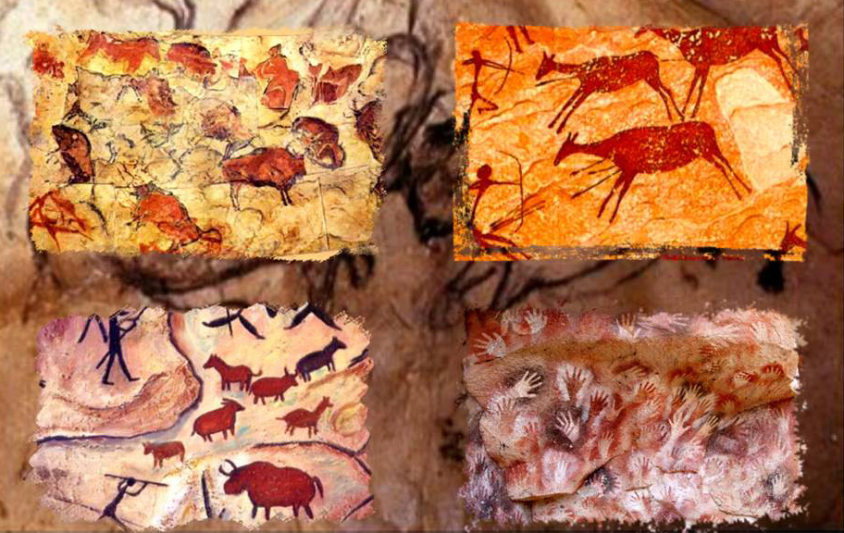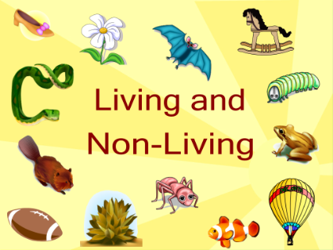

Use any materials you can find at home to make an artefact for our class museum**.**

Create your family tree (Try and include your great-grandparents if possible).

SCAVENGERS & SETTLERS

Create a poster to advertise a movie about the Ice Age.

Write a short report on the Celtic movement. What did they use?

Write about how fossils are made.

Create a timeline showing the Stone Age.

Write about the Bronze and Iron Age movements.

Look at the food in your kitchen cupboards. Look closely at the packaging. What countries do we get our food from?

Research and write about tools used in the Stone Age.

Year 3 Homework SUMMER ONE

Choose 1 activity to complete each week and hand in to your class teacher on Thursday morning. You should complete at least 5 activities, but you may do more if you wish.