PUPIL PREMIUM

ST JOHN AND ST JAMES CE PRIMARY SCHOOL

PUPIL PREMIUM STRATEGY 2018/2019

SCHOOL CONTEXT
St John & St James CE primary school is an average primary school serving a rapidly changing community on the boarders of Enfield and Haringey. Statistical data shows a steady increase in the % of EAL pupils joining the school. The school deprivation indicator is significantly higher than the national average and the % of FSM pupils although decreasing, is now 33%. (ROL 2016)
St John & St James CE provides a harmonious, happy learning environment where pupils feel valued and listened to. We aim to provide a secure but exciting atmosphere to support pupils to gain a joy of learning. We pride ourselves on being an inclusive school where the promotion of Christian values underpins our practices. Our mission statement ‘Believe and Achieve’ helps our pupils learn the importance of self awareness, self responsibility and resilience.
Our key objective in using the Pupil Premium Grant is to diminish the differences between pupil groups. As a school we consistently track all groups of pupils to ensure that they make good or better progress. Through targeted interventions we are working to eliminate barriers to learning and progress. For new entrants that start with low attainment on entry, our aim is to ensure that they make accelerated progress in order to reach age related expectations as they move through the school. Once at age related expectations we always continue to extend that learning further to ensure that they reach higher levels of attainment.The Pupil Premium funding per pupil for 2018 – 2019 is as follows:
Type of Pupil | Pupil Premium per Pupil
Pupils recorded as FSM | £1,320
Looked after children All pupils leaving the local authority care for  the following reasons  - Adoption  - A special guardianship order  - A child arrangements order  - A residence order | £1,900

OUR APPROACH

Funding has been ring-fenced and used to benefit all pupil premium pupils. We have established clear lines of responsibility with all members of the senior leadership team for ensuring PP pupils achieve well as they move through the school. We ensure that we track PP pupil’s achievement and that all staff know which pupils need additional support to either support or extend their learning. We also identify most able PP pupils.
This has meant making informed decisions about our spending such as:
* Ensuring that spending is directly linked to differences in achievement
* Providing for additional support for children who may require emotional and social intervention
* Making use of our own data to expand existing interventions
* Making sure there is at least good teaching on a day to day basis
* Appointing additional teachers or staff to support pupils to make better than expected progress
* Providing the opportunity for pupils to attend Saturday School and booster sessions weekend, after school hours and school holidays
The attached Pupil Premium Strategy Statement includes the details of how we are improving outcomes for PP pupils including the most able. The statement also reviews expenditure

 | Number of pupils and pupil premium grant (PPG) received
 |  | 2013 - 2014 | 2014 - 2015 | 2015 - 2016 | 2016 – 2017 |  |  |  | 2017 - 2018 | 2018 - 2019
Total number of pupils on roll – Reception to Year 6  - Nursery to Year 6 |  | 411 | 413  443 ( Sept 14) | 454( Sept 15) | 430  456( Sept 16) |  |  |  | 428  440( Sept 17) | 397  404 (Sept 18)
Total number of pupils eligible for PPG |  | 136 | 135 | 151 | 137 |  |  |  | 133 | 105
Percentage of pupils eligible for PPG  - Based on current numbers excluding nursery |  | 33.1% | 32.6% | 33.4% | 33.1% |  |  |  | 31% | 26.4%
Amount of PPG received per eligible puils  ( includes Free School Meals pupils and Looked After Children) |  | £750 | £1300 | £1320 | £1320 |  |  |  | £1320 | £1320
Total amount of PPG received |  | £102,000  £127,647 | £198,000 | £199,320 | £204,000 |  |  |  | £204,000 | £160,000

Pupil premium Strategy Statement

- Summary information
School | St John & St James CE Primary School
Academic Year | 2018 - 2019 | Total PP budget | £160,000 | Date of most recent PP Review |  |  | N/A
Total number of pupils | 404 | Number of pupils eligible for PP | 105 | Date of next PP Strategy Review |  |  | February 2019

At St John & St James we have high aspirations and ambitions for our children and we believe that no child should be left behind. We are determined to ensure that our children are given every chance to believe in themselves and aspire to achieve well.

The Government believes that the Pupil Premium, which is additional to main school funding, is the best way to address the current underlying inequalities between children eligible for free school meals (FSM) and their wealthier peers by ensuring that funding to tackle disadvantage reaches the pupils who need it most.

It is for school to decided how the Pupil Premium, allocated to schools per FSM pupils, is spent, since they are the best placed to assess what additional provision should be made for the individual pupils within their responsibility. However, they will be held accountable for how they have used the additional funding to support pupils from low income families.

As a school we consistently track all groups of pupils to ensure that they make good or better progress. Through targeted interventions we are working to eliminate barriers to learning and progress. For new entrants that start with low attainment on entry, our aim is to ensure that they make accelerated progress in order to reach age related expectations as they move through the school. Once at age related expectations we always continue to extend that learning further to ensure that they reach higher levels of attainment. We closely monitor how we are spending the allocated funds to ensure they are having an impact on pupil premium pupil’s achievement.

- Barriers to future attainment ( for pupils eligible for PP)
In-School barriers ( issues to be address in school, such as poor oral language skills)
A | PP pupils do not always make better than expected progress from their starting points.  PP pupils are below all pupils in all year groups and need to make accelerated progress in all areas.
B | PP pupils make less than expected progress especially in the Autumn terms in all years.
C | A significant number of PP pupils are EAL and some families have limited English language to support their children at home.
D | Fewer more able PP pupils are achieving greater depth in reading, writing and maths at the end of KS1 and KS2
External barriers ( issues which also require action outside school such as low attendance, poor punctuality

E | Parental support at home can lead to a dip in performance and less progress
F | Attendance for our PP in 2017/2018 was 94.9%. This is below our school target of 96%.
G | Some home environments have limited reading materials due to family circumstances and access to English.
H

- Outcomes ( Desired outcomes and how they will be measured) |  | Success criteria
Pupil Premium Impact and Spend 2018 /2019
( Linked to School Development Plan)
Identified Barrier to learning | Internal or External | How we intend to overcome the barrier | Our measure of success | Lead Person | Budget | Budget Category
Written language skills are lower in PPG children across the school. | Internal and  External | Many children at school have limited opportunities to broaden life experiences and develop personal interests. | Increased participation in extra curricular clubs over the year and children making good progress. |  |  | Staffing – Teaching
Reading skills are lower in PPG across the school. | Internal | Many children at school have limited opportunities to read to an adults daily and develop personal interests. | Evidence of enjoyment for reading and children making good progress. |  |  | Staffing – Teaching /  Support
Mathematics skills are lower in PPG across the school. | Internal and External | Many children at school have limited opportunities to broaden life experiences and develop personal interests. | Increased participation in extra curricular clubs over the year and children making good progress. |  |  | Staffing – Teaching
Attendance amongst PPG pupils is lower | Internal | We give a weekly award to the class with the highest attendance.  Termly attendance reports to all children falling below 95% | 95% attendance in PPG pupils |  |  | Non – Staffing costs
Behaviour: having a readiness to learning with good ‘behaviours for learning’ in school | Internal | Additional TA hours have been allocated to provide further support to PPG pupils with specific reading and writing difficulties | Evidence of narrowing the gap |  |  | Staffing – Teaching /Support

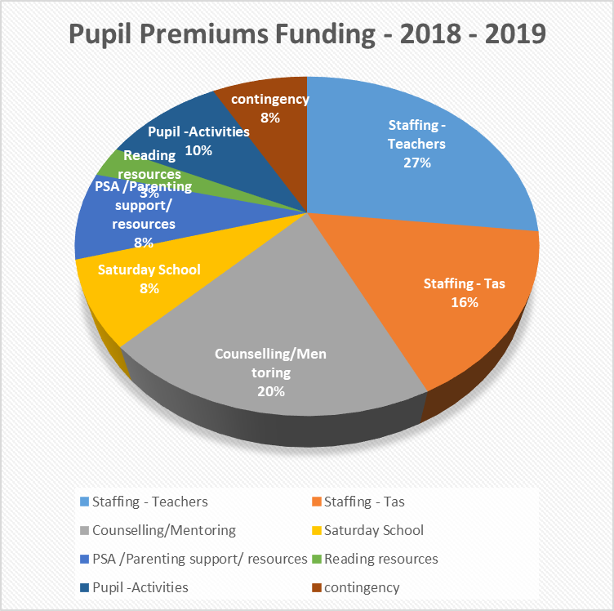

- REVIEW of PP strategy
Academic year | 2018 - 2019
The three headings below enable schools to demonstrate how they are using the Pupil Premium to improve classroom pedagogy, provide targeted support and support whole school strategies.
- Quality of teaching for all
Desired outcome | Chosen action / approach | What is the evidence and rationale for this choice? |  | How will you ensure it is implemented well?  Success Criteria | Estimated impact: Did you meet the success criteria? Include impact on pupils not eligible for PP, if appropriate.
Improve reading skills for pupils eligible for PP  Continue to improve the language skills for pupils eligible for PP especially subject specific vocabulary to support their reading skill.  Continue to improve reading outcomes for all pupils.  Improve the % of PP pupils passing phonics screening | Daily supported reading programme for reception and KS1 ( targeted children)  DSR daily reading programme for all pupils in KS2 working below ARE.  Whole class phonics in year 1 and year 2 , twice a day.  Introduce whole school reading programme for year 3 -6 to focus on developing comprehension skills. ( Destination Reader) | There is evidence that this programme has shown positive outcomes in other local schools in KS1 reading.  Tracking data in the school shows that pupils in Nursery and Reception made above expected progress in Yr 1 when given regularly additional reading support.  Daily reading activity by trained staff and/or volunteers.  A new phonics programme was introduced in year 1 last year. There was a significant improvement in the teaching of phonics. Phonic teaching will take place twice a day in KS1. A Catch up phonic session will be held for children in Y3/Y4 and new to English.  .  Most able PP targeted to extend learning.  National Literacy Trust research identifies the importance of reading for pleasure and its impact on literacy attainment and other outcomes.  In the past the school has subscribed to ReBel training through the LA.  The introduction of the MIDAS programme in year 6 is supplemented by DESTINATION READER in years 3 to year 6 from September 2018.  There are a significant number of children who are not able to access Destination Reader and therefore the introduction of smaller, targeted support reading groups from end of Nov.18 were introduced. |  | . Success criteria  - PP pupils make above the expected progress each term in reading  -80% of PP pupils pass the phonics screening in year 1  - Increase by 20% the PP pupils passing the phonics retakes in year 2 to 65% (  EYFS results in reading:- target 65%  KS1 results in reading- target 70% ( ARE)  KS2 results in reading – target 65% (ARE) | DSR programme is to continue in year 1 and reception for 2019-2020. Whilst a good % of pupils are on target to reach the expected standard this can still improve to ensure that outcomes reflect other at the end of EYFS in reading.  At present the evidence is showing that this target may not be reached. The monitoring of, and quality of phonics sessions will need to be continued in 2019-2020.  Progress across the school for all reading appears to be on target for all children and PP. The results at the end of the year will impact on whether this support has led to an increase in better than expected progress for all.  A named member of SLT must take a lead on PP to ensure closer tracking systems, review provision and ensure greater accountability at Pupil achievement meetings (PAMS)

- Targeted support

Desired outcome | Chosen action / approach | What is the evidence and rationale for this choice? | How will you ensure it is implemented well? Success Criteria. | Estimated impact: Did you meet the success criteria? Include impact on pupils not eligible for PP, if appropriate.
Accelerate progress of all PP pupils – writing ,maths and other areas of the curriculum | Support staff running intervention groups in phonics and writing.  Part time teachers, AHT, DHT to provide targeted support and teaching by providing interventions where needed in writing and maths. | Some pupils need targeted support to diminish differences and to have individual support matched to their needs.  This approach was used last year and shown to be effective when staff are trained.  The data for PP pupils shows they must continue to make accelerated progress to diminish the differences with all pupils nationally. | . Success criteria  - PP pupils make above the expected progress each term in writing, maths and other areas of the curriculum – target %
Provide support for EAL PP pupils | Provide all EAL pupils with a rich language experience in class and through small group support.  EMA Lead to identify and track progress of EAL PP pupils  Induction programme adapted to meet the needs of individual EAL pupils. | Past data shows that progress in this group is variable.  EAL pupils need intervention to support them to develop fluency when speaking English.  Starting points of EAL learners will vary according to their age, level of English and school experience. | . . Success criteria  - PP pupils, who are EAL, make above the expected progress each term in reading and maths.
Increasing the number of PP pupils reaching the higher standard in reading and writing at the end of KS1 and KS2 | SLT to identify PP most able KS1 pupils and year 5 and 6.  Target all above pupils to attend extra curricular clubs –newspaper club / librarians/ maths club.  Intervention support from staff.  Provide high quality home reading materials. | The school data shows that we need to increase the number of most able PP pupils reaching a higher standard.  Nationally PP do less well at the higher levels therefore this needs to be a focus for all schools.  We have focussed on reading and writing as this impacts access to all aspects of the curriculum  Extra teaching time before and after school to run additional groups.  Saturday school for identified children.- made available for y5/y6 pupils.  Produce a list of targeted pupils and track progress.  Whole school use of Mathletics and Spellodrome to encourage work at home. | Success criteria  Increase the number of PP pupils reaching a higher standard across the school – track at the start of Autumn and end of Summer 2019 the number of PP pupils exceeding  1Increase % of PP gaining higher standard at end of KS2 to ensure they are in line with non PP
Desired outcome | Chosen action / approach | What is the evidence and rationale for this choice? | How will you ensure it is implemented well? Success Criteria. | Estimated impact: Did you meet the success criteria? Include impact on pupils not eligible for PP, if appropriate.
Provide for the emotional needs of all PP pupils | SLT to identify pupils who require emotional support in order to help children establish a good attitude to learning.  School counselling service to provide individual and small group support. | The school data shows that we need to increase the number of most able PP pupils reaching a higher standard.  Nationally PP do less well at the higher levels therefore this needs to be a focus for all schools  Provision of a nurture group for identified KS1 pupils and KS2 pupils for part of each day | .Provision of 1:1 counselling support.  % of PP pupil receiving support.  Improved learning behaviours for all pupils who attend sessions. Good progress in learner and fewer negative behaviour and incidents in and around school.

- Other approaches

Desired outcome | Chosen action / approach | What is the evidence and rationale for this choice? | How will you ensure it is implemented well? Success Criteria. | Estimated impact: Did you meet the success criteria? Include impact on pupils not eligible for PP, if appropriate.
Increase parental engagement through workshops and PSA role  Support parents wanting to support their children further at home | Senior leaders and subject leads to deliver workshops to parents.  Weekly coffee morning to be established to provide regular opportunities for parents to know how to read with their child.  SHARE programme to support EYFS parents in helping their child at home.  PSA to work in partnership with parents and school – to provide stability for pupils  Monthly homework club for parents and their children to be established to provide regular opportunities for parents to know how to help their child. | Parents are key in supporting effective learning as shown by a number of research projects ( Sutton Trust)  Pupil Achievement meetings show that those pupils who make accelerated progress have a supportive home environment where they regularly read to an adult and complete homework.  Attendance information at workshops to be analysed to ensure we are reaching the appropriate parents.  PSA to be briefed on targeting parents to attend.  Reading workshops to be planned and supported by the Literacy Lead.  The PSA will work to support families and signpost them to agencies to meet their individual needs.- housing, immigration, domestic violence
Desired outcome | Chosen action / approach | What is the evidence and rationale for this choice? | How will you ensure it is implemented well? Success Criteria. | Estimated impact: Did you meet the success criteria? Include impact on pupils not eligible for PP, if appropriate.
Improve attendance of PP pupils | AO and PSA to focus on PP pupil’s attendance  AO to alert SLT of any concerns so they can be involved in working with the family  PP attendance to be a focus for the PP termly report  Evaluate the impact of actions taken through a halftermly attendance report AO to regularly update SLTwith punctuality rates for PP pupils | We know that attainment for all pupils can be improved with good attendance.  Targeting families and promoting the importance of good attendance is essential to improving outcome for all. | 1. Increase PP attendance by 1%  2. Reduce PA by 3% to bring this in line with the national of 8.8%  3. Reduce the number of PP arriving late for school
Provide extra curricular activities for PP pupils | Clubs and activities outside the classroom enhance learning opportunities. | We know that not will exceed in academic subjects and therefore it is important to give all children to opportunity to find a skill and develop it. | Funding will be used to pay staff to run afterschool clubs and activities for targeted PP pupils.  Provision for PP pupils to attend BTC and TTC club.  .

