[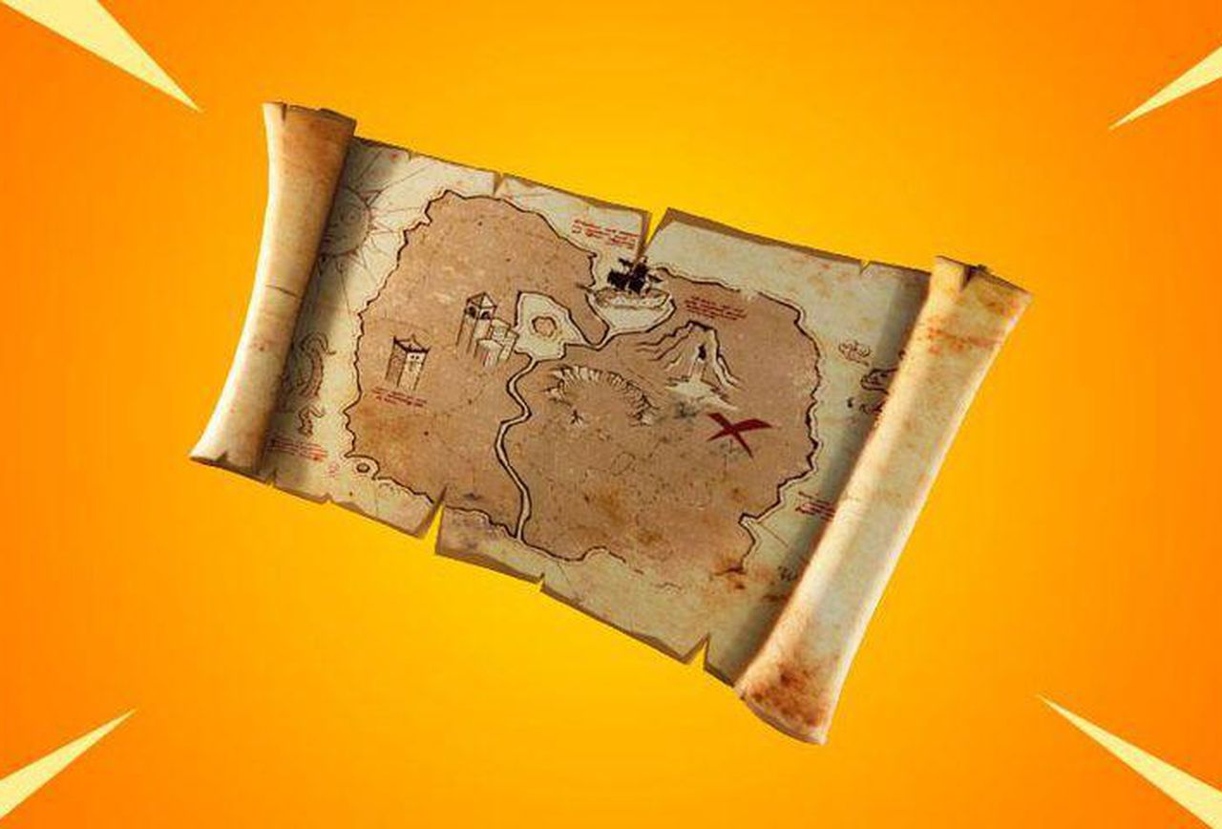](https://www.forbes.com/sites/davidthier/2019/03/21/fortnite-challenge-guide-where-and-how-to-search-for-buried-treasure/)

It is precious- Using pasta, beads, or some other materials can you make your own necklace, crown, bracelet, ring or watch to put in our treasure chest?

Nursery Homework Summer 1

Please choose 1 activity to complete each week.

Can you find any stories or rhymes about pirates or treasure. Bring them into Nursery to show your friends.

[EYFS@Stjohnandjames.enfield.sch.uk](mailto:EYFS@Stjohnandjames.enfield.sch.uk)

We would love to see photos of the things that you have been doing at home and at the weekends. Send them in to us at school on the email above so that we can talk about it together.

Treasure

My Treasure box Using a shoe box make your own treasure chest. You might like to draw some of your own treasure to go into the box.

My Map Make your own treasure map. Can you draw an x to shoe where the treasure is? Bring your map in to show your friends.

Special to me - Take a photo of something at home that is very precious to you. Send it in to us at [EYFS@Stjohnandjames.enfield.sch.uk](mailto:EYFS@Stjohnandjames.enfield.sch.uk) so we can print it out and stick it into your book.

Shape Picture- Using triangles, squares, circles and rectangles, make your own shape picture. You might like to create a ship or a treasure chest