[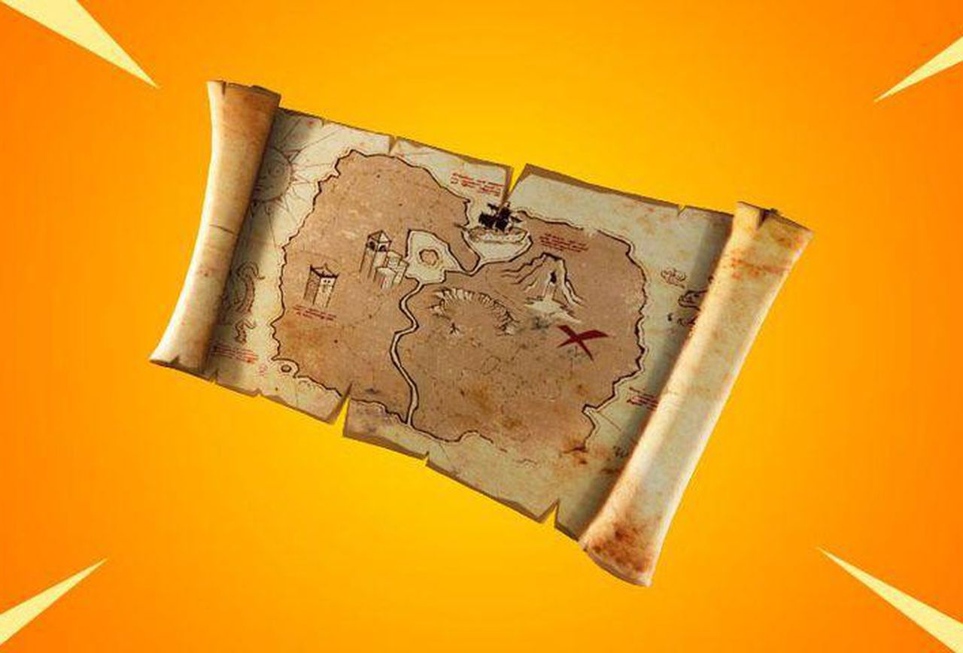](https://www.forbes.com/sites/davidthier/2019/03/21/fortnite-challenge-guide-where-and-how-to-search-for-buried-treasure/)

Reception Homework Summer 1

Choose 1 activity to complete each week and hand in to your class teacher on Thursday morning. You should complete at least 6 activities, but you may do more if you wish.

It is precious- Using pasta, beads, or some other materials can you make your own necklace, crown, bracelet, ring or watch to put in our treasure chest?

What have you used to make it? Can you write a sentence to explain?

[EYFS@Stjohnandjames.enfield.sch.uk](mailto:EYFS@Stjohnandjames.enfield.sch.uk)

We would love to see photos of the things that you have been doing at home and at the weekends. Send them in to us at school on the email above so that we can talk about it together.

How many? Go around your house and count how many of the following you can find.

Pencils - Tables – Curtains - Doors –

What would 1 more and 1 less be for each of these objects?

Treasure

My Treasure box Using a show box make your own treasure chest. You might like to draw some of your own treasure to go into the box or write a list of the treasure you might find in your box.

My Map Make your own map of your journey to school. What do you pass on the way? Draw the things that you pass and mark the school on the map.

Special to me - Take a photo of something at home that is very precious to you. Send it in to us at [EYFS@Stjohnandjames.enfield.sch.uk](mailto:EYFS@Stjohnandjames.enfield.sch.uk) and write a sentence about your picture.

Shape Picture- Using 2d shapes make your own 2d picture. You might like to create a ship, a treasure chest, a pirate or something else you might find on an island.