[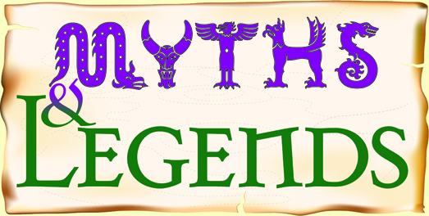](http://www.google.co.uk/url?sa=i&rct=j&q=&esrc=s&source=images&cd=&cad=rja&uact=8&ved=2ahUKEwjGg4_fvZLeAhWy4IUKHU3vAjcQjRx6BAgBEAU&url=http://www.crablane.manchester.sch.uk/print.php?page_no%3D%26category_id%3D349%26return%3D1;&psig=AOvVaw0ZhGp_yk4NQW8ivCqt2Dpy&ust=1540037718873408)

Write a persuasive speech about why mythical creatures should be allowed to go to school.

Imitate the work of Sandra Ducheiwicz by drawing or painting a mythical creature.

Create a mask of a mythical creature.

Create a song or rap about mythical creatures.

Write a diary entry as a mythical creature.

To research and create a fact files about 5 different mythical creatures.

Research a famous author who writes books about mythical creatures and write a biography about the author.

Write a letter to Theseus from the Minotaur.

Year 5 Homework Autumn Two

Choose 1 activity to complete each week and hand in to your class teacher on Thursday morning. You should complete at least 5 activities, but you may do more if you wish.

Create and describe your own mythical creature.