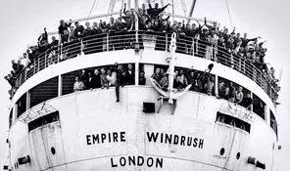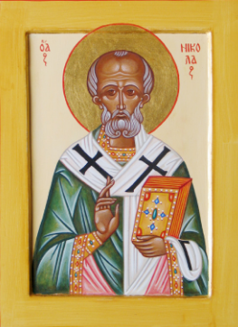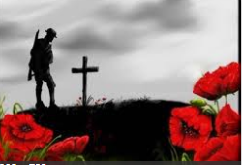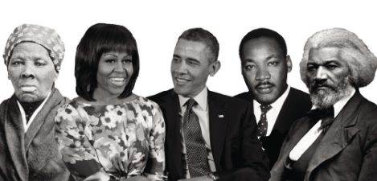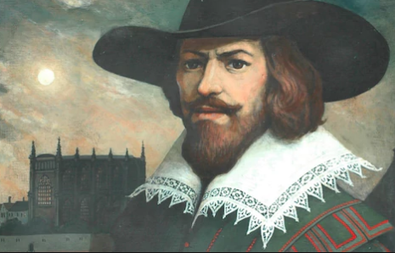

Time Detectives

**What is Windrush? Why is it important in British history?**

**Find out why Guy Fawkes is remembered on November 5th.**

**Please draw a poppy and write about why people wear poppies every year around November 11th.**

**October was black history month. Write about somebody you think is important to mark this celebration.**

**Year 1 Homework- Autumn 2**

Choose one activity to complete each week and hand in to your class teacher on **Thursday morning.**  You should complete at least five activities, but you can do more if you wish.

**Talk to your parents and grandparents about a favourite family recipe. Write this recipe out to share to your class.**

**Find out how people celebrated Christmas 100 years ago. Are there any differences or similarities?**

**Please find out about St. Nicolas and why he is important at Christmas time.**

**Learn a range of poems by heart. Please learn: crackle! Spit! By Marie Thom.**