International Primary Curriculum
Class Link Countries –2017 - 2018
Nursery | St Peter |  |  |  |  | St Paul
Reception | St Christopher | ENGLAND |  | 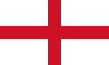 |  | St Nicholas |  | ENGLAND |  | 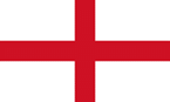
Year One | St Mary and St Andrew | SCOTLAND | 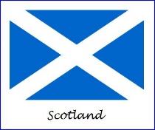 |  | WALES |  | 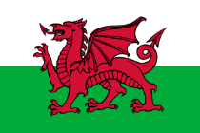 |  | NORTHERN  IRELAND  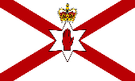
Year Two | St Elizabeth | CANADA |  |  |  | St Francis |  | FRANCE |  | 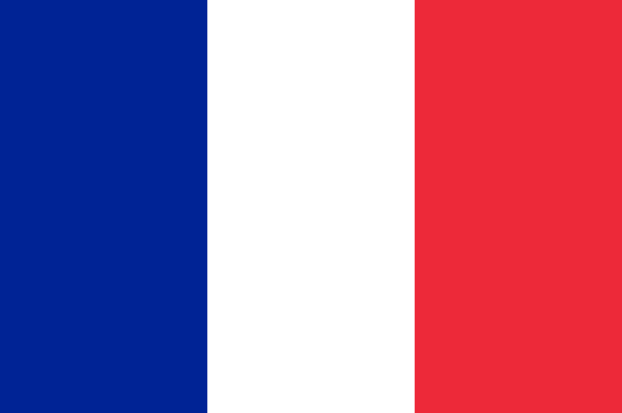
Year Three | St James | MEXICO |  | 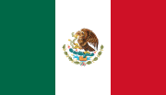 |  | St David |  | JAPAN
Year Four | St George | ITALY |  |  |  | St Winifred |  | INDIA
Year Five | St Teresa | NAMIBIA |  | 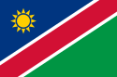 |  | St Patrick |  | MALAYSIA |  | 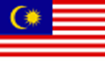
Year Six | St John the Baptist | GERMANY |  | 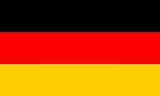 |  | St Joan Of Arc |  | SOUTH AFRICA |  | 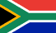

As each class moves throughout the school they take with them their link country. This gives the children to opportunity to learn in greater depth through new curriculum topics new aspects of their link country.

