 | St John & St James CE Primary School Curriculum Plan – 2018-19
 | Autumn One | Autumn Two | Spring One | Spring Two | Summer One | Summer Two
EYFS | All about Me | Patterns | Transport | Houses and Homes | Treasure | Plants and Flowers
 | Entry Point: | Entry Point: | Entry Point: | Entry Point: | Entry Point: | Entry Point:
 |  | 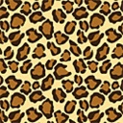 | 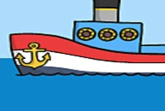 | 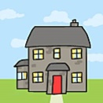 | 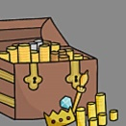 | 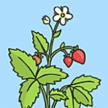
 | Exit Point. | Exit Point. | Exit Point. | Exit Point. | Exit Point. | Exit Point.
Year 1 | Time Travellers | The Toymaker | What’s it made of? | Media Magic | Treasyre | The Stories People Tell
 | Entry Point: | Entry Point: | Entry Point: | Entry Point: | Entry Point: | Entry Point:
 | 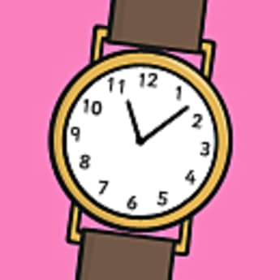 | 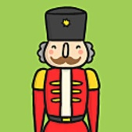 |  |  |  | 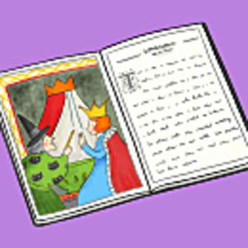
 | Exit Point. | Exit Point. | Exit Point. | Exit Point. | Exit Point. | Exit Point.
Year 2 | The Earth, our home | People from the Past |  | All Dressed Up | Hooray! Let’s go on holiday | Super Humans
 | Entry Point: | Entry Point: | Entry Point: | Entry Point: | Entry Point: | Entry Point:
 |  |  |  |  | 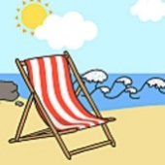
 | Exit Point. | Exit Point. | Exit Point. | Exit Point. | Exit Point. | Exit Point.
Year 3 | Brain Waves  Active Planet | Bright Sparks | Digital Gamers | How Humans Work | Scavengers and Settlers | Different People Similar Lives
 | Entry Point: | Entry Point: | Entry Point: | Entry Point: | Entry Point: | Entry Point:
 | 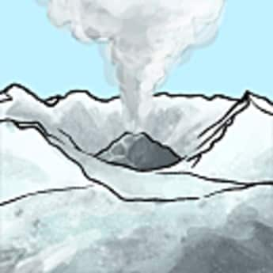
 | Exit Point. | Exit Point. | Exit Point. | Exit Point. | Exit Point. | Exit Point.
Year 4 | Temples. Tombs and treasures | Shake it! | Rainforest | Rainforest | Living together | Living together
 | Entry Point: | Entry Point: | Entry Point: | Entry Point: | Entry Point: | Entry Point:
 | 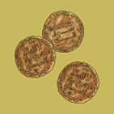 |  | 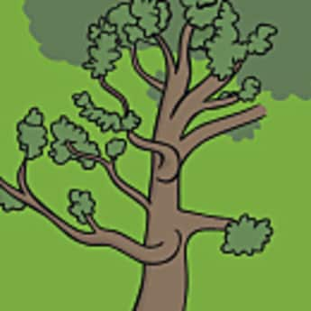 |  | 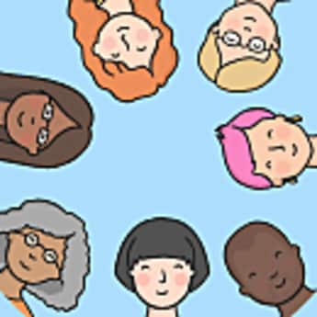020  .
 | Exit Point. | Exit Point. | Exit Point. | Exit Point. | Exit Point. | Exit Point.
Year 5 | Mission to Mars | The Great, the bold and the brave | Making things go | Extreme survivors | Making the news
 | Entry Point: | Entry Point: | Entry Point: | Entry Point: | Entry Point: | Entry Point:
 | 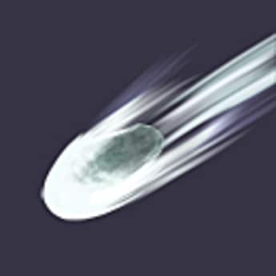 | 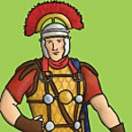 | 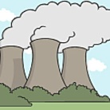 | 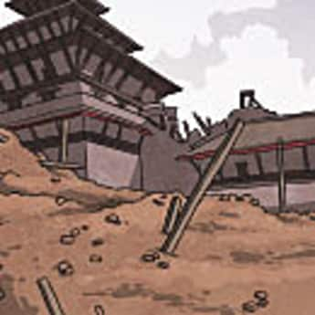
 | Exit Point. | Exit Point. | Exit Point. | Exit Point. | Exit Point. | Exit Point.
Year 6 | Moving People | Fit for Life | Climate control
 | Entry Point: | Entry Point: | Entry Point: | Entry Point: | Entry Point: | Entry Point:
 |  | 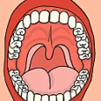
 | Exit Point. | Exit Point. | Exit Point. | Exit Point. | Exit Point. | Exit Point.

 | St John & St James CE Primary School Curriculum Plan- - 2017-18
 | Autumn One | Autumn Two | Spring One | Spring Two | Summer One | Summer Two
EYFS | All about Me | Animals | Up up & away | Let’s Pretend | Changes/Growth | Sand & Water
 | Entry Point: | Entry Point: | Entry Point: | Entry Point: | Entry Point: | Entry Point:
 | Exit Point. | Exit Point. | Exit Point. | Exit Point. | Exit Point. | Exit Point.
Year 1 | Time Travellers | The Toymaker | What’s it made of? | Media Magic | Our World | The Stories People Tell
 | Entry Point: | Entry Point: | Entry Point: | Entry Point: | Entry Point: | Entry Point:
 | Exit Point. | Exit Point. | Exit Point. | Exit Point. | Exit Point. | Exit Point.
Year 2 | The Earth, our home | People from the Past |  | All Dressed Up | Hooray! Let’s go on holiday | Super Humans
 | Entry Point: | Entry Point: | Entry Point: | Entry Point: | Entry Point: | Entry Point:
 | Exit Point. | Exit Point. | Exit Point. | Exit Point. | Exit Point. | Exit Point.
Year 3 | Brain Waves  Active Planet | Bright Sparks | Digital Gamers | How Humans Work | Scavengers and Settlers | Different People Similar Lives
 | Entry Point: | Entry Point: | Entry Point: | Entry Point: | Entry Point: | Entry Point:
 | Exit Point. | Exit Point. | Exit Point. | Exit Point. | Exit Point. | Exit Point.
Year 4 | Temples. Tombs and treasures | Shake it! | Rainforest | Rainforest | Living together | Living together
 | Entry Point: | Entry Point: | Entry Point: | Entry Point: | Entry Point: | Entry Point:
 | Exit Point. | Exit Point. | Exit Point. | Exit Point. | Exit Point. | Exit Point.
Year 5 | Mission to Mars | The Great, the bold and the brave | Making things go | Making the news | Existing, Endangered | Bake It
 | Entry Point: | Entry Point: | Entry Point: | Entry Point: | Entry Point: | Entry Point:
 | Exit Point. | Exit Point. | Exit Point. | Exit Point. | Exit Point. | Exit Point.
Year 6 | Moving People | Fit for Life | Climate control
 | Entry Point: | Entry Point: | Entry Point: | Entry Point: | Entry Point: | Entry Point:
 | Exit Point. | Exit Point. | Exit Point. | Exit Point. | Exit Point. | Exit Point.

