RE  This term AT SCHOOL the children will be:learning about the Life of Jesus – growing up, miracles and parables.  - Celebrating EASTER  PE/Games  This term AT SCHOOL the children have  PE & Games: Monday and Wednesday  Please ensure that your child has the correct PE kit labelled and plimsolls in school each week.  HOMEWORK  In Year One the homework will be:  - Homework diaries for the children to write in each week, which are to be returned by Tuesday each week at the latest.  - A piece of literacy or numeracy each week.  - Key words, tricky words and phonics each week.  - Book bags will come home each evening but books may only be changed once a week.  CLASS VISITS  Year one will be going on several short walks around the school and local area including vistiing Fore Street Library and St Johns the Evangelist Church, Dysons Road. The children will also be attending a visit to the Bruce Grove museum, The children will be recording their observations during the visits. | St John & St James CE Primary School  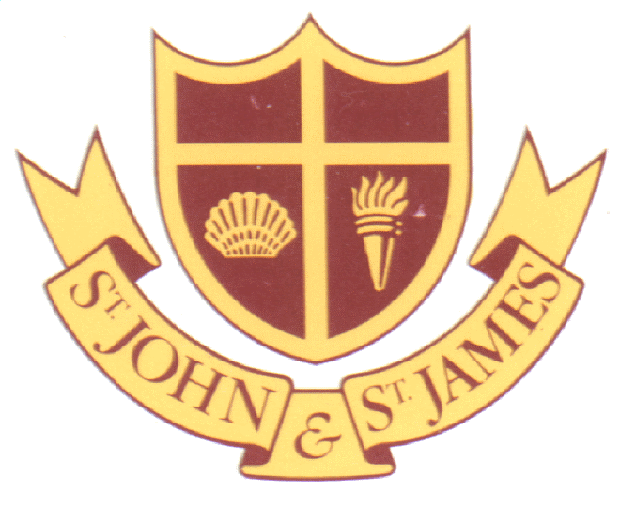  Spring Term 2018  Learning Objectives  Year One – St Andrew Class – 1A  Class Teacher: Mrs McGovern/Ms Ayres Rodriguez  This booklet will tell you what your child will be learning this term and contains some ideas for homework. We hope you will find this booklet helpful as you continue to support and encourage your child at home with their learning.

English  This term AT SCHOOL the children will be learning about;  - rhymes and rhyming stories  - contemporary fiction  - traditional tales  - non fiction texts  - Dictionary work  - Writing reports.  AT HOME you could:  - read traditional tales and encourage your child to talk about their favourite characters.  - read rhyming poetry to your child and encourage them to guess the last word of a rhyming line  - you could purchase a simple dictionary for your child to practice searching for words and their meanings.  - You could encourage your child to keep a simple diary of a special outing or visit.  Mathematics  This term AT SCHOOL the children will be:  - Reading the time on an analogue clock – o’clock and half past  - Counting forwards and backwards in 1s,10s,5s and 2s,  - To know what each number in a 2 digit number represents  - Talk about 1 and 10 more or less  - Addition and subtraction to 20. Doubling and halving  - Money – finding the totals –  - Measurement of weight..  AT HOME you could:  - play simple maths games such as snakes and ladders and frustration to encourage number recognition and sequencing of numbers.  - Play simple money games using real coins. Encourage your child to recognize and use coins up to the value of 20p/  - Encourage your child to help in the kitchen by weighing items and following simple recipes | Science  This term AT SCHOOL the children will be:  Learning about materials  - Classifying and sorting materials.  - Know that each material serves a different purpose.  Learning about plants  - Investigate different types of plants including trees.  - Identify what it is that a plant needs to live  AT HOME you could:  - Look at plants in the local environment.  - discuss the items and food that some plants help us to produce.  - discuss recycling  - look at the materials used to make different objects and discuss why they think this is.  International Primary Curriculum ( IPC)  The International Primary Curriculum ( IPC) is a 21st century curriculum which extends children’s knowledge, skills and understanding in subjects by developing personal attributes and supporting an international perspective in a way that responds to the changing world around us. IPC is an internationally-minded curriculum which is used in over 60 countries.  By using IPC we are able to nurture a love of learning and encourage the necessary key skills and personal qualities; such as team work, research and creativity, flexibility and thoughtfulness which will help children to become able and inspired learners. In additional to this, children will extend their knowledge and understanding of communities beyond that of our own country by exploring many aspects of other societies and ways of living.  This term’s topics are: 'What's it made of?' and 'Media magic'

